 Methods Unit 3 Test 2, 2018

(Calculator Free)

Time: 18 minutes Marks: 18

1. [2, 2 marks]

a) Evaluate

= [t3 - 2t2 + t] ✓

= 12 ✓

b) Evaluate exactly

= [0.5e2x-1] ✓

=0.5e3 – 0.5e ✓

1. [2, 2, 1 marks]

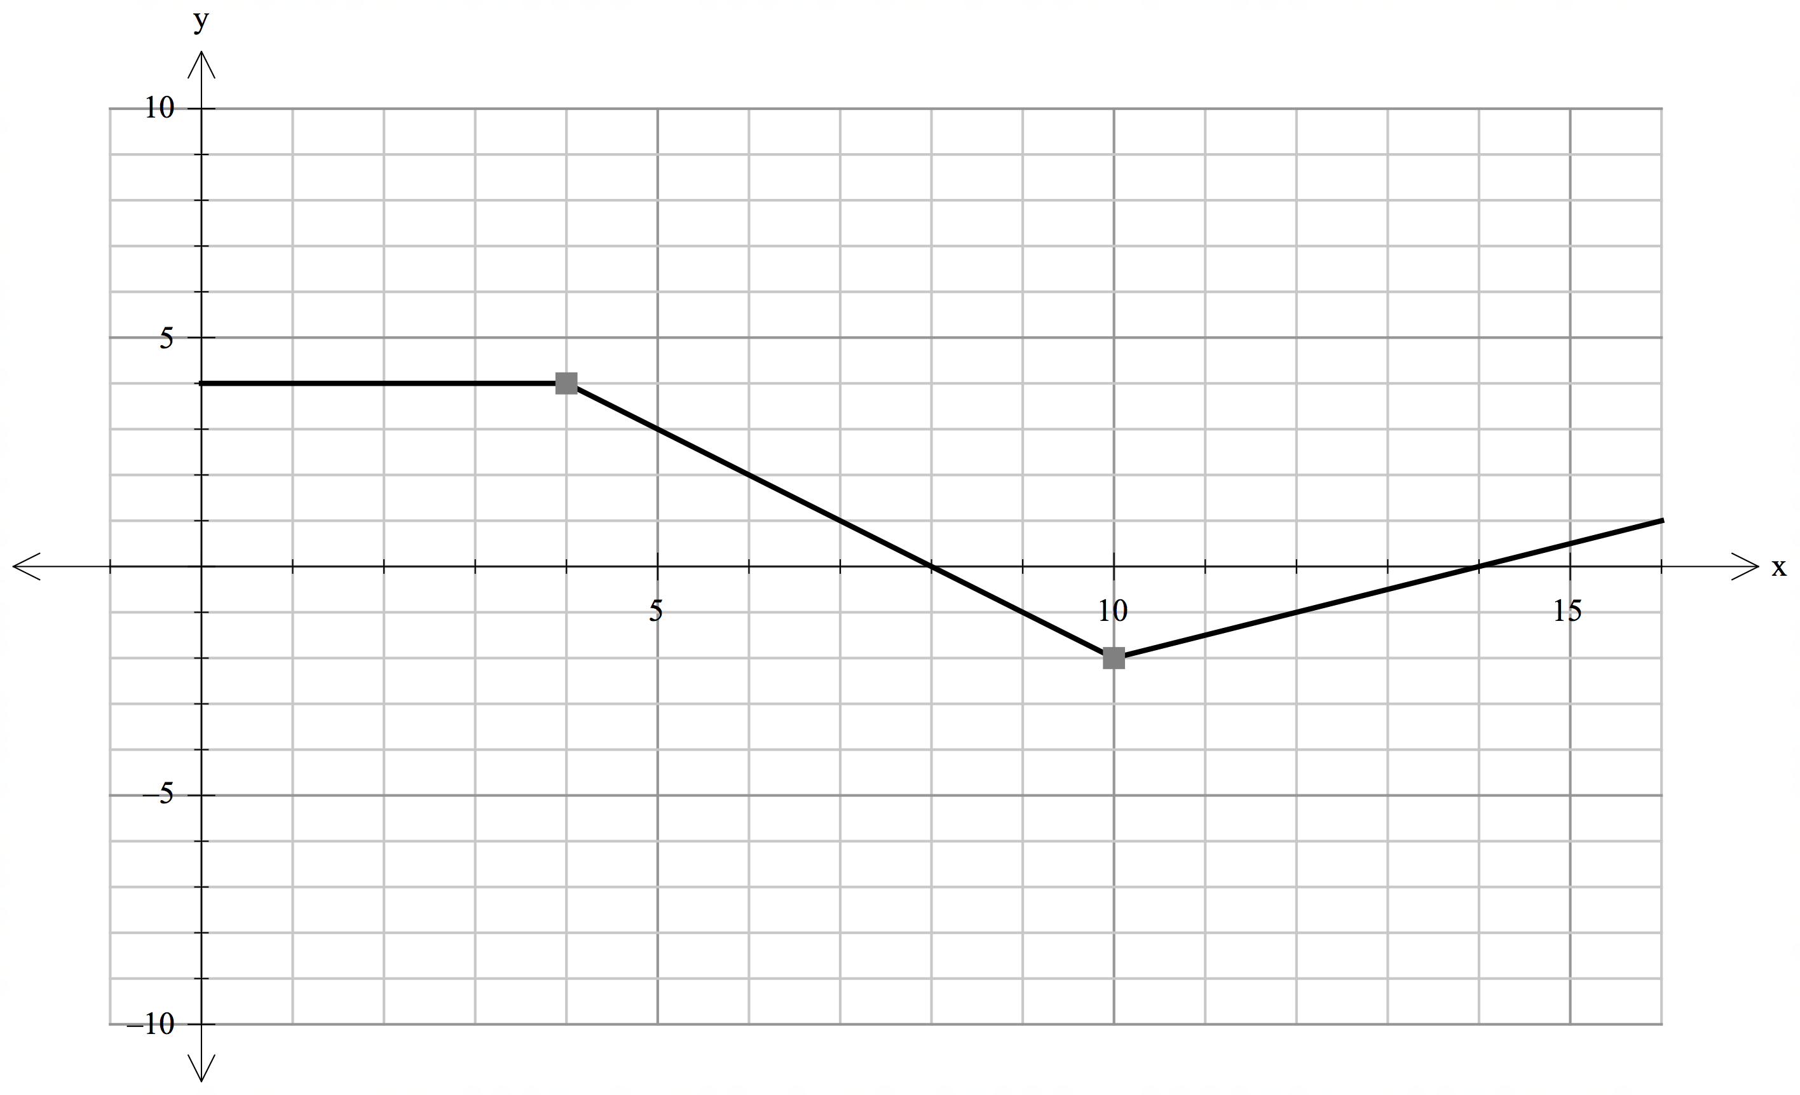

Use the diagram of y = f(x) above to determine the following:

a) $\int_{0}^{10}{f\left(x\right) dx}$ = 16 + 8 – 2 ✓

= 22 ✓

b) $\int_{8}^{16}{f\left(x\right) dx}$ = -4 + 1 ✓

= -3 ✓

c) The value of *a*, given $\int_{10}^{a}{f\left(x\right) dx}$ = 0 and a > 0

a = 18 ✓

3. [4, 3 marks]

a) Determine the tangent to the curve y = 2 + e-x at the point where x = 1.

$\frac{dy}{dx}$ = - e-x ✓

If x = 1 then $\frac{dy}{dx}$ = - $\frac{1}{e}$ ✓

If x = 1, y = 2 + $\frac{1}{e}$ ✓

Thus the tangent is y – 2 - $\frac{1}{e}$ = - $\frac{1}{e}($ x – 1) or y = - $\frac{1}{e}x$ + $\frac{2}{e}$ + 2 ✓

b) Determine the exact area bounded by the curve y = 2 + e-x, x = 0, x = 3 and the x-axis.

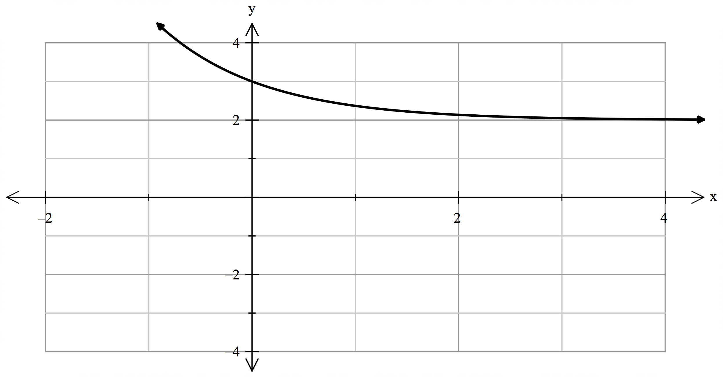

$\int_{0}^{3}{2+e^{-x}}$ dx = [2x –e-x] ✓

= 6 – e-3 – (- 1) ✓

= 7 - ✓

4. [2 marks]

Determine [

[ ✓

= 4x2 – x ✓

 Methods Unit 3 Test 2, 2018

(Calculator Assumed)

Time: 36 minutes Marks: 36

1. [2, 3 marks]

a) From your Classpad, determine any points of intersection of the curves y = x3 – x2 + 3x – 5 and y = 3 + x - 6x2. State these points of intersection.

(-4, -97) (-2, -23) (1, -2) ✓ ✓

b) Demonstrating calculus techniques, find the area between these two curves.

$\int_{-4}^{1}{|\left(x^{3}-x^{2}+3x-5\right)-(}3+x-6x^{2})| dx$ ✓

= $\int_{-4}^{1}{\left|x^{3}+5x^{2}+2x-8\right|}$ dx ✓

= 21.08 units2  ✓

6. [1, 2, 3, 3 marks]

The instantaneous rate of growth of rabbits in a colony is 12% per month. Initially there are 50 rabbits.

a) Express the population in terms of P = P0 ekt.

P = 50 e0.12t ✓

b) How many rabbits will there be in one year?

P = 50 e0.12(12) ✓

= 211 rabbits ✓

c) If left unchecked, when will the population exceed 1 000? Give your answer to the nearest month.

1000 = 50 e0.12t ✓

e0.12t = 20 ✓

Solving this t = 25 months ✓

d) When the rabbits are exposed to the calicivirus, the population decreases from 1000 to 100 in

12 months. Determine the instantaneous rate of decline (as a percentage, correct to 1 decimal place) in the rabbit population.

100 = 1000 e12k ✓

e12k = 0.1 ✓

Solving this k = -0.1919

This is a decline of 19.2% per month ✓

7. [1, 3, 2 marks]

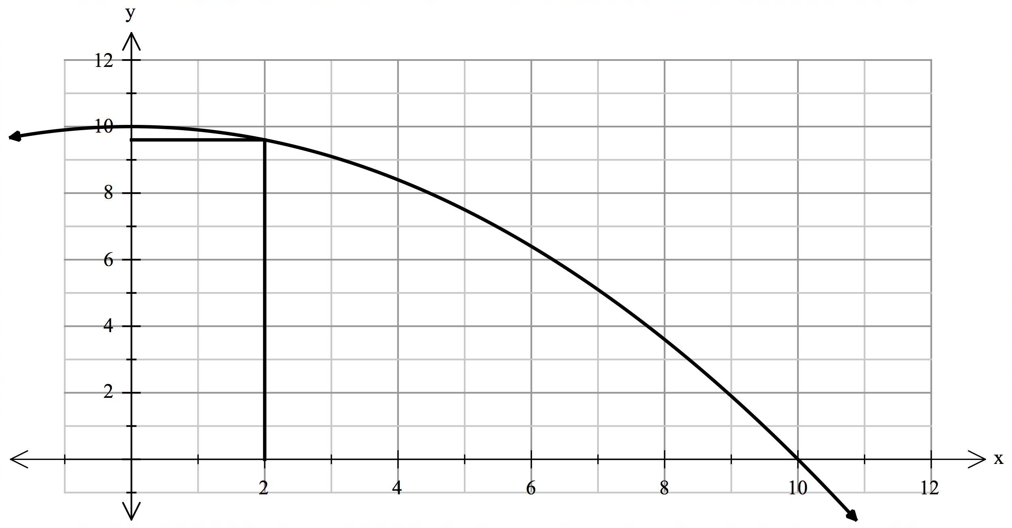

y = 10 - 0.1x2

1. Using the diagram above to complete this table:

|  |  |  |  |  |  |  |
| --- | --- | --- | --- | --- | --- | --- |
| x | 0 | 2 | 4 | 6 | 8 | 10 |
| y | 10 | 9.6 | 8.4 | 6.4 | 3.6 | 0 |

* ½ per error

b) Using this table, the “overestimate” of the area under y = 10 - 0.1x2 is 76 square units. By “underestimating” the area, determine an approximate value for the area under this curve.

A = 2 x (9.6 + 8.4 + 6.4 + 3.6) ✓

= 56 units2 ✓

Average = 66 units2 ✓

c) Find the area using calculus techniques.

$\int_{0}^{10}{10-.1x^{2}}$ dx ✓

= 66.67 units2 ✓

8. [3, 3 marks]

In a recent published article by the Bureau of Statistics, it took 35 months for the population of Australia to increase from 23 million to 24 million. If we assume the rate of growth can be modeled by $\frac{dP}{dt}$ = kt, where P is the population at time t,

a) determine k

24 = 23 e35k ✓

e35k = 1.04348 ✓

Solving this k = 0.001216 ✓

b) determine how long it will take to grow from 24 million to at least 25 million.

24e0.001216t = 25 ✓

e0.001216t = 1.04167 ✓

Solving this t = 33.6 months ✓

9. [4 marks]

If $\frac{dQ}{dt}$ = ${6e}^{3t}$ and Q = 3 when t = 0, find the exact value of Q when t = -1

+ c ✓

If t = 0, Q = 3 thus c = 1 ✓

Q = 2e3t + 1 ✓

If t = -1, then Q = + 1 ✓

10. [6 marks]

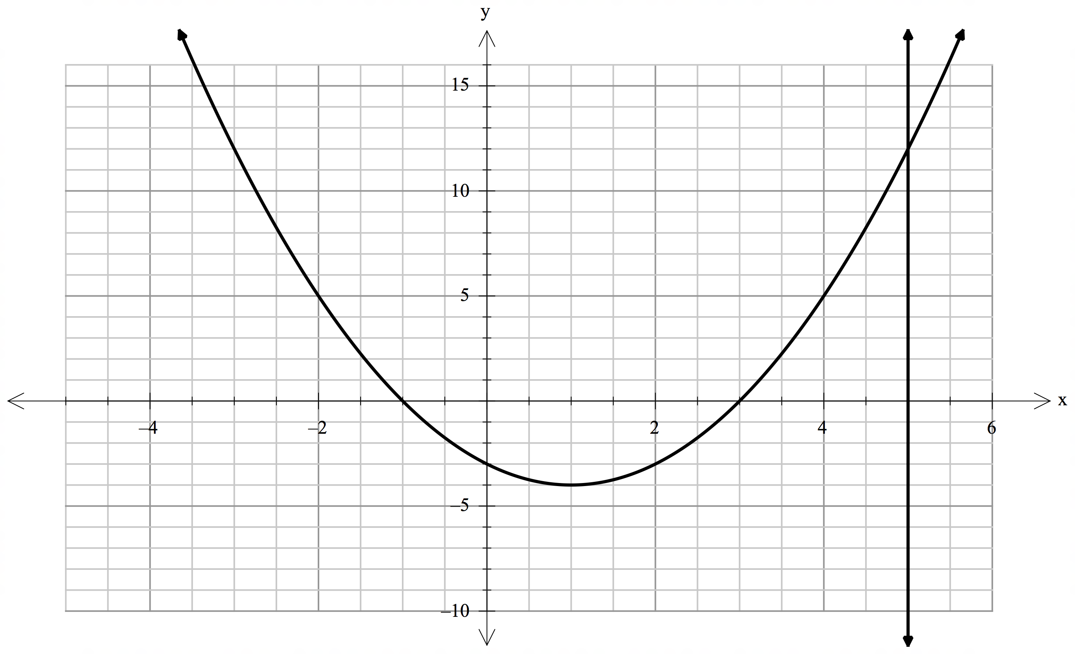

B

A

The diagram above shows the curve y = x2 - 2x - 3 and the line x = k.

A

Given that Area A = Area B, determine k.

**Note:** Full working must be shown to be awarded all marks.

2 – 2x – 3 dx = - 10.67 ✓

$\int_{3}^{k}{x^{2}-2x-3 dx= 10.67}$ ✓

[ $\frac{x^{3}}{3}$- ${ x}^{2}$- 3x ] = ✓

- 3k + 9 = $\frac{32}{3}$ ✓

Solving this k = -1 or 5 ✓

Thus k = 5 ✓